ABSTRACT
Background: Right ventricular outflow tract (RVOT) aneurysms are uncommon, typically occurring after congenital heart defect repairs, while idiopathic presentations are exceedingly rare. Concomitant pulmonary stenosis increases right ventricular afterload and mediastinal compression. We report the surgical management of a rare, non-operated giant RVOT aneurysm compressing critical mediastinal structures.
Method: A 28-year-old male presented with a 3-year history of orthopnea, chest heaviness, and palpitations. Imaging revealed severe pulmonary stenosis (peak gradient 80 mmHg) and an 119 × 88 mm RVOT aneurysm encasing the ascending aorta, superior vena cava, pulmonary trunk, and right ventricle. Cardiopulmonary bypass was established using axillo-bicaval cannulation to avoid hazardous central arterial access. The aneurysmal sac was completely excised following meticulous dissection of the pulmonary arteries. Outflow tract reconstruction was achieved using a transannular pericardial patch, and pulmonary valve replacement was performed with a 23A TTK Chitra tilting-disc mechanical valve.
Result: The patient was extubated within 12 hours and successfully discharged on postoperative day 7 following an uneventful hospital stay. Postoperative transesophageal echocardiography demonstrated a reduced peak pulmonary valve gradient of 18 mmHg and preserved biventricular function (ejection fraction 58%). Follow-up CT pulmonary angiography confirmed complete aneurysm excision and relief of mediastinal vessel compression.
Conclusion: Giant RVOT aneurysms with pulmonary stenosis require tailored surgical planning. Axillo-bicaval cannulation, complete excision, pericardial patch RVOT augmentation, and pulmonary valve replacement offer safe, effective anatomical reconstruction and excellent functional hemodynamics.

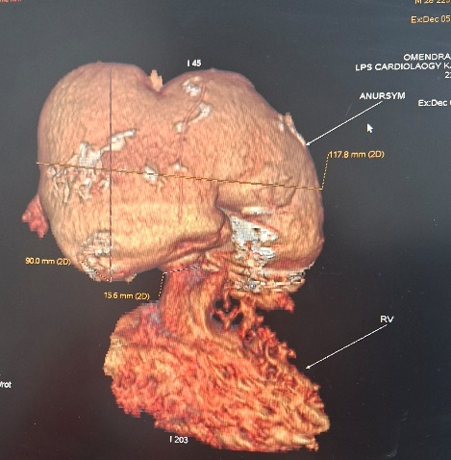
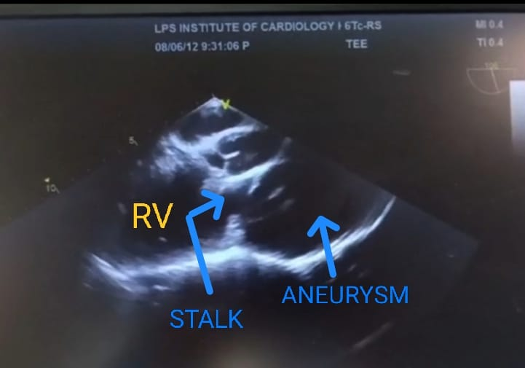
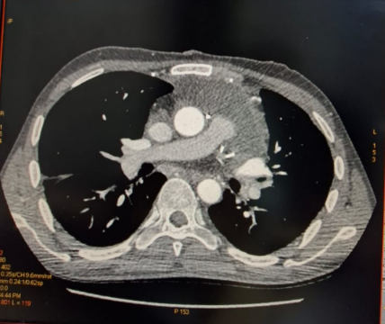
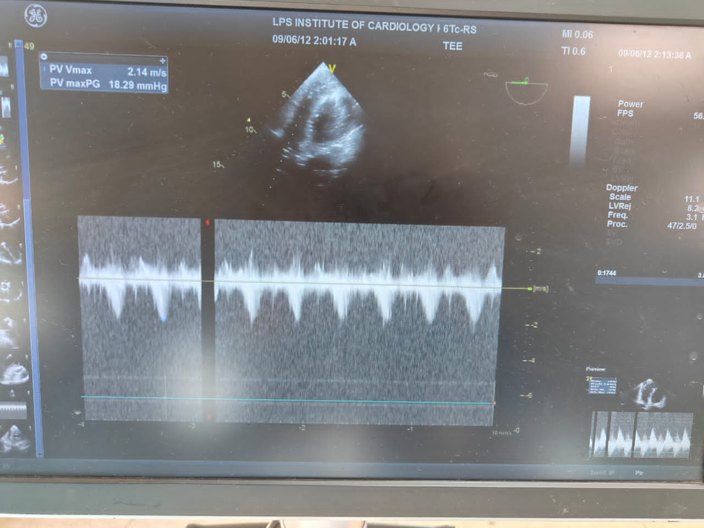
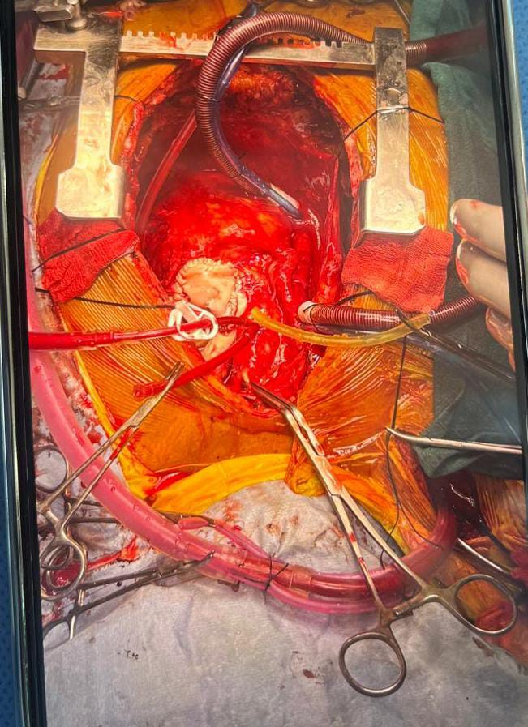
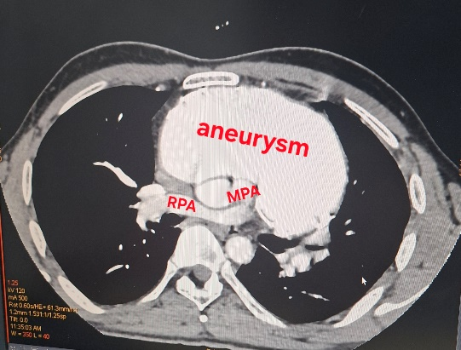
Fig. 6- Postoperative CT Pulmonary angiography shows complete excision of aneurysm.
Fig. 5 - Postoperative TEE demonstrated a reduction in pulmonary valve gradient to 18mmHg
Fig. 4- MPA was augmented with pericardial patch, which was fixed with 5-0 prolene.
Fig. 3- Cardiac CT showing giant RVOT aneurysm encasing of ascending aorta, SVC, pulmonary trunk and most of RV
Fig. 2- 3D image showing large outpouching through a narrow neck from RV measuring 119x88mm.

Fig. 1- TEE shows mid esophageal aortic long axis view showing large RV aneurysm with stalk of 1.8cm

